REAL-TIME RESEARCH PROJECT ABSTRACT (A14)
TITLE OF THE PROJECT: SECURE DOCUMENTS MANAGEMENT SYSTEMS
Roll number | Student name | Ph.no | Email id
24891A6614 | D.BHOOMIKA | 8328305937 | deshaboinabhoomika237@gmail.com
24891A6628 | K.AKSHAYA | 9014037464 | Katkuriakshaya1@gmail.com
24891A6608 | B.JAYADAR | 6309097085 | bijilijayadar@gmail.com
24895A6602 | B.UDAY KIRAN | 8340855723 | bj555980@gmail.com
GUIDE NAME: Mr. .K GOPI
ABSTRACT
A Secure Document Management System incorporates advanced security mechanisms such as user authentication, access control, encryption, audit logging, and secure backup. These features help prevent unauthorized access, data breaches, and information loss. SDMS is widely used in sectors such as healthcare, banking, education, government, and corporate enterprises where data security and regulatory compliance are essential.
Step-by-Step Process of Secure Document Management System
Step 1: User Registration and Authentication
Users register in the system using secure credentials. Authentication mechanisms such as passwords, multi-factor authentication, or biometric verification ensure that only authorized users can access the system.
Step 2: Role-Based Access Control
Users are assigned roles (e.g., admin, manager, employee). Each role has predefined permissions to view, edit, upload, or delete documents, ensuring restricted access to sensitive data.
Step 3: Document Upload and Classification
Authorized users upload documents into the system. Documents are categorized and tagged based on type, sensitivity level, or department for easy retrieval and management.
Step 4: Encryption and Secure Storage
Uploaded documents are encrypted using strong cryptographic algorithms before being stored in the database or cloud storage to protect against unauthorized access.
Step 5: Document Access and Version Control
Users can securely view or edit documents based on their access rights. Version control ensures that all changes are tracked and previous versions can be restored if required.
Step 6: Audit Logging and Monitoring
The system maintains logs of all user activities, including document access and modifications, to ensure accountability and detect suspicious behaviour.
Step 7: Backup and Recovery
Regular backups are performed to prevent data loss. Recovery mechanisms allow restoration of documents in case of system failure or cyberattacks.

BLOCK DIAGRAM / CIRCUIT DIAGRAM

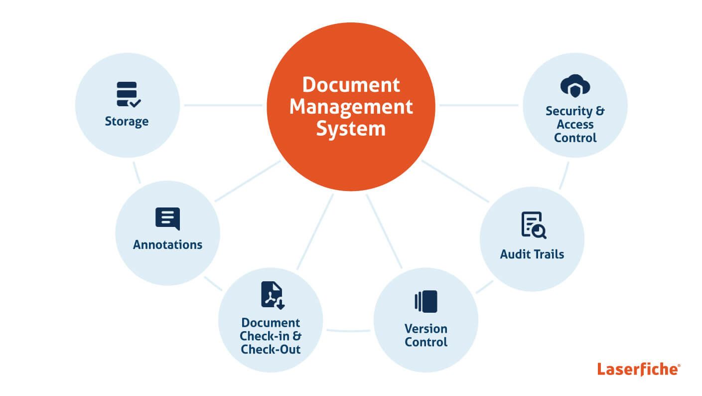

MR.K GOPI
GUIDE NAME & SIGNATURE HOD – CSE (AI&ML)

